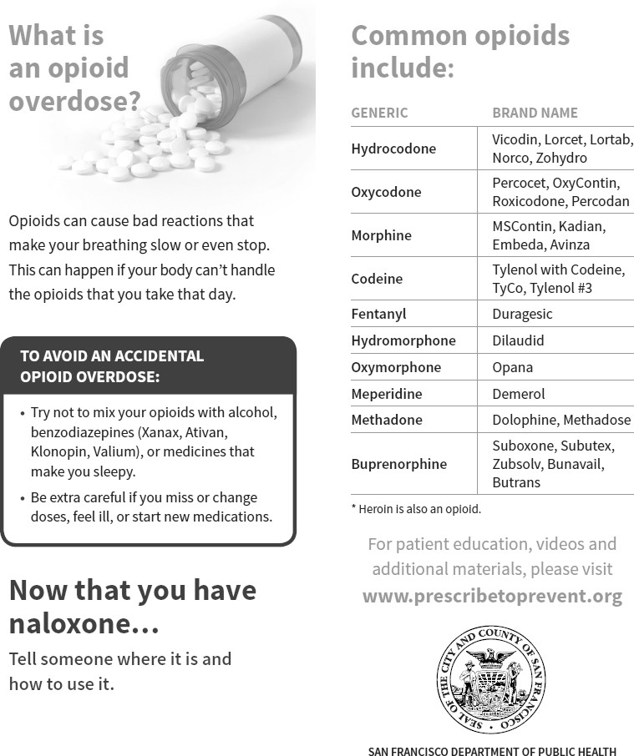

**Opioid safety**

**and how to use naloxone**

**What is an opioid**

**overdose?**

Common opioids include:

**GENERIC BRAND NAME**

Opioids can cause bad reactions that make breathing slow or even stop. This can happen if your body can’t handle the opioids that you take that day. Many drugs are now cut/contaminated with fentanyl, which is much more potent that other opioids and is causing increases in overdoses and deaths.

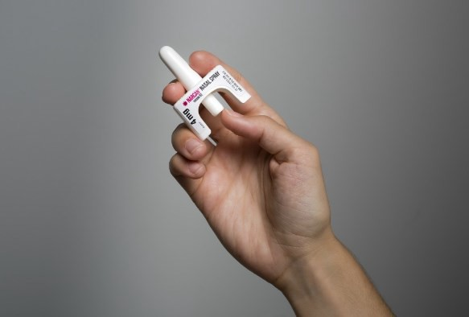

**TO AVOID AN ACCIDENTAL**

**OPIOID OVERDOSE:**

* Try not to mix your opioids with alcohol, benzodiazepines, (Xanax, Ativan, Klonopin, Valium), or medicines that make you sleepy.
* Be extra careful if you miss or change doses, feel ill, or start new medications.
* Use a test dose and fentanyl test strips.



**A GUIDE FOR**

**COMMUNITY MEMBERS**

For more information on regional efforts to curb opioid misuse, call (530) 283-7099 or go to [www.opioidsafety.com](http://www.opioidsafety.com/)

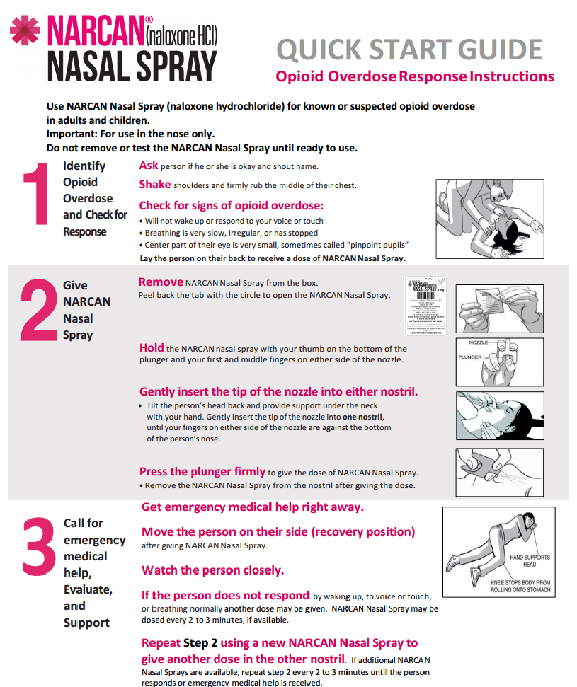

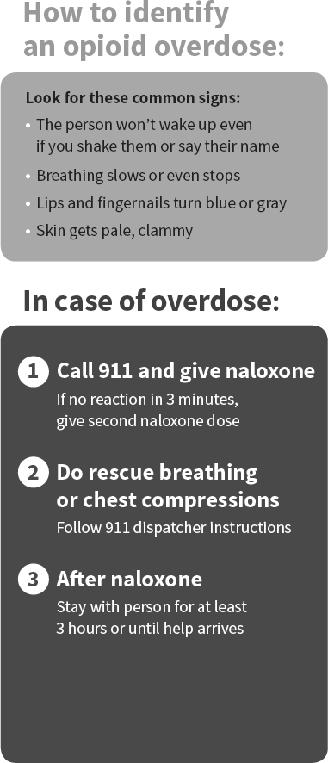

**How to identify**

**an opioid overdose:**

**Look for these common signs:**

* **The person won’t wake up even if you shake them or say their name**
* **Breathing slows or even stops**
* **Lips and fingernails turn blue or gray**
* **Skin gets pale, clammy**